Smart
Laundry system for automated dosing applied to industrial laundry machines.

Table of contents
1 Initial information …………………………………………………….. Page 3
2 Installation………………………………………………………………. Page 5
3 Console….…………………..…………………………………………. Page 13
4 Level and flush kit.………………………………………………….... Page 17
5 Maintenance and accessories….……………………………………. Page 19
6 Trouble-shooting guide………………………………………….……. Page 20
7 How to contact us.…………………………………………………… .. Page 21

Assembly drawing of the Smart System
1
Preliminary information
- Welcome
- Contents of the package
- Technical specifications
- Warnings
- Material required for installation

2
Installation

3
Console

4
Level and flush kit

5
Maintenance and accessories

6
Trouble-shooting guide

7
How to contact us

Smart boxes
Delivery tube 20 Bar (only for “PLUS” configuration)
Water-faucet for water delivery (only for “PLUS” configuration)
Delivery solenoid valve (24 VDC) (only for “PLUS” configuration)
Solenoid valve filter
Flush kit (only for “PLUS” configuration)
Peristaltic pump
Peristaltic tube
Suction device (optional)
Control console
Programmer (optional)
Level monitoring device (optional)

1 Preliminary information…
1
Preliminary information
- Welcome
- Contents of the package
- Technical specifications
- Warnings
- Material required for installation

2
Installation

3
Console

4
Level and flush kit

5
Maintenance and accessories

6
Trouble-shooting guide

7
How to contact us

1.1 Welcome
Thank you for purchasing a Seko product.
With the Smart system for industrial laundry machines, our company supplies a high-quality product suitable for all applications. It is simple to use thanks to linear programming of the washing cycles and to the user-friendly way in which the programs are selected.

➲ Pay special attention to the warnings and to the precautions pointed out in the manual.

1.2 Contents of the package
Before starting, check the contents of the package:

SMART BASIC | SMART PLUS
SMART System without flush kit (pump unit and control console with 5 m of cable) | SMART System with flush kit (pump unit and control console with 5 m of cable)
2 off anti-tampering seals | 2 off anti-tampering seals
 | Instruction manual and adhesive sheet for programs
Instruction manual and adhesive sheet for programs | 4 off anchor bolts ∅=6 mm, 2 off brackets for securing the pump unit in place
 | 15 off plastic clamps for the hydraulic connections
15 off plastic clamps for the hydraulic connections | Adhesive Velcro strip for securing the control console in place
Adhesive Velcro strip for securing the control console in place | Tube fitting ∅16mm for output from flush kit
 | 5m of 14-wire cable (for connection of the power-supply and signals coming from the laundry machine).
5m of 14-wire cable (for connection of the power-supply and signals coming from the laundry machine). | water-intake kit: water-faucet, delivery tube 2 m F3/4-F3/4 (optional 3-4-5 m).
 | 1 off Sekobril tube for Surfactants
1 off Sekobril tube for Surfactants | 1 off Memory Cards
1 off Memory Cards

Technical specifications
Power-supply requirements | 85-230 Vac switching (mod. H) | 115/208/230 Vac linear (mod. P)
Maximum current absorption | 100W (mod. H) | 30W (mod. P)
Flow rate of pumps | 30/60/90/120 L/h (mod. H) | 18 L/h (mod. P)
Voltage on inputs | 20-230 Vac or 150-230Vac, selectable JP1 to JP6
Number of inputs | 6, opto-insulated. Input n° 6 also counts the number of deliveries
Class of protection | IP 65 (Smart inox: IP 40
Alarm output (optional) | Relay-type contact NC in an alarm condition, 250V 8A max

1.4 Warnings
1
Preliminary information
- Welcome
- Contents of the package
- Technical specifications
- Warnings
- Material required for installation

2
Installation

3
Console

4
Level and flush kit

5
Maintenance and accessories

6
Trouble-shooting guide

7
How to contact us

 Read this manual carefully before proceeding with the installation and starting up the SMART System.
 The dosing unit should be connected to the power supply by means of a single-pole breaker having an opening distance equal to or greater than 3 mm.
Check the model of the equipment purchased for the reference information contained in this manual for installing, setting and programming it.

For all connections, refer to the diagram of the control circuit contained in this manual.

 CAUTION: Always follow the appropriate safety procedures, including the use of suitable means for protecting the eyes, face, hands and clothing.

 CAUTION: Always disconnect the equipment from the power supply before carrying out the installation or any maintenance work on it.

➲ Seko is working constantly to improve all its products, and reserves the right to make changes at any time without prior notice.

➲ Failure to comply with the instructions contained in this manual could cause damage to property or personal injury, prejudice proper functioning of the equipment or damage it.

1.5 Material required for installation
- SMART programmer
- Plastic clamps of various sizes for securing the tubes and cables in place
- Adhesive plates for securing the clamps
- Graduated container, recommended size 250 ml (for calibrating the pumps)
- PVC tube (for connecting the flush kit to the laundry machine)

➲ Other installation material is also available (see chapter 5, Maintenance and Accessories).

2 Installation

1
Preliminary information

2
Installation
- Wall mounting
- Diagrams: control and power-supply circuits
- Wiring connections
- Selection of flow rate of the pumps
- Hydraulic connections
- Anti-tampering seal

3
Console

4
Level and flush kit

5
Maintenance and accessories

6
Trouble-shooting guide

7
How to contact us

CAUTION: Do not install the equipment where it would be directly exposed to chemical vapours or fumes. DO not place it close to the sources of heat.

2.1 Wall mounting
- Use the diagram shown below to define the distance between centres for drilling the holes, depending on the total length of the boxes.
- It is advisable to install the system at a height of about 1.5 metres from the ground, and in any case in the vicinity of the tanks.
- Fix the mounting brackets to the wall by means of the anchor bolts ∅=6 mm (Picture 1).
- After securing the brackets in place, hang the SMART System from them, as shown in the Picture (Picture 2).
Long box L=375mm Short box L=285mm
Key to distance between centers for drilling the holes
1 long box…………………………….. i= 190 mm
1 long box + 1 short box…………… i= 425 mm
2 long boxes………………………….. i= 564 mm
2 short boxes ……...……………… i= 285 mm
1 long box + 2 short boxes………… i= 659.5 mm

65 mm
i

Take care to secure the brackets to the wall correctly, since any errors in centring them would make it difficult to mount the SMART equipment.

Picture 1 Picture 2

If the surface of the wall is not perfectly flat, making it difficult to mount the brackets, it is possible to secure the box directly to the wall, drill through the breaking lines inside each box and fix the box to the wall using anchor bolts ∅=6 mm. In order to not prejudice the IP protection degree, it is advisable to apply silicone to the screws inside the box.

2.2.1 Control circuit diagram
1
Preliminary information

2
Installation
- Wall mounting
- Diagrams: control and power-supply circuits
- Wiring connections
- Selection of flow rate of the pumps
- Hydraulic connections
- Anti-tampering seal

3
Console

4
Level and flush kit

5
Maintenance and accessories

6
Trouble-shooting guide

7
How to contact us

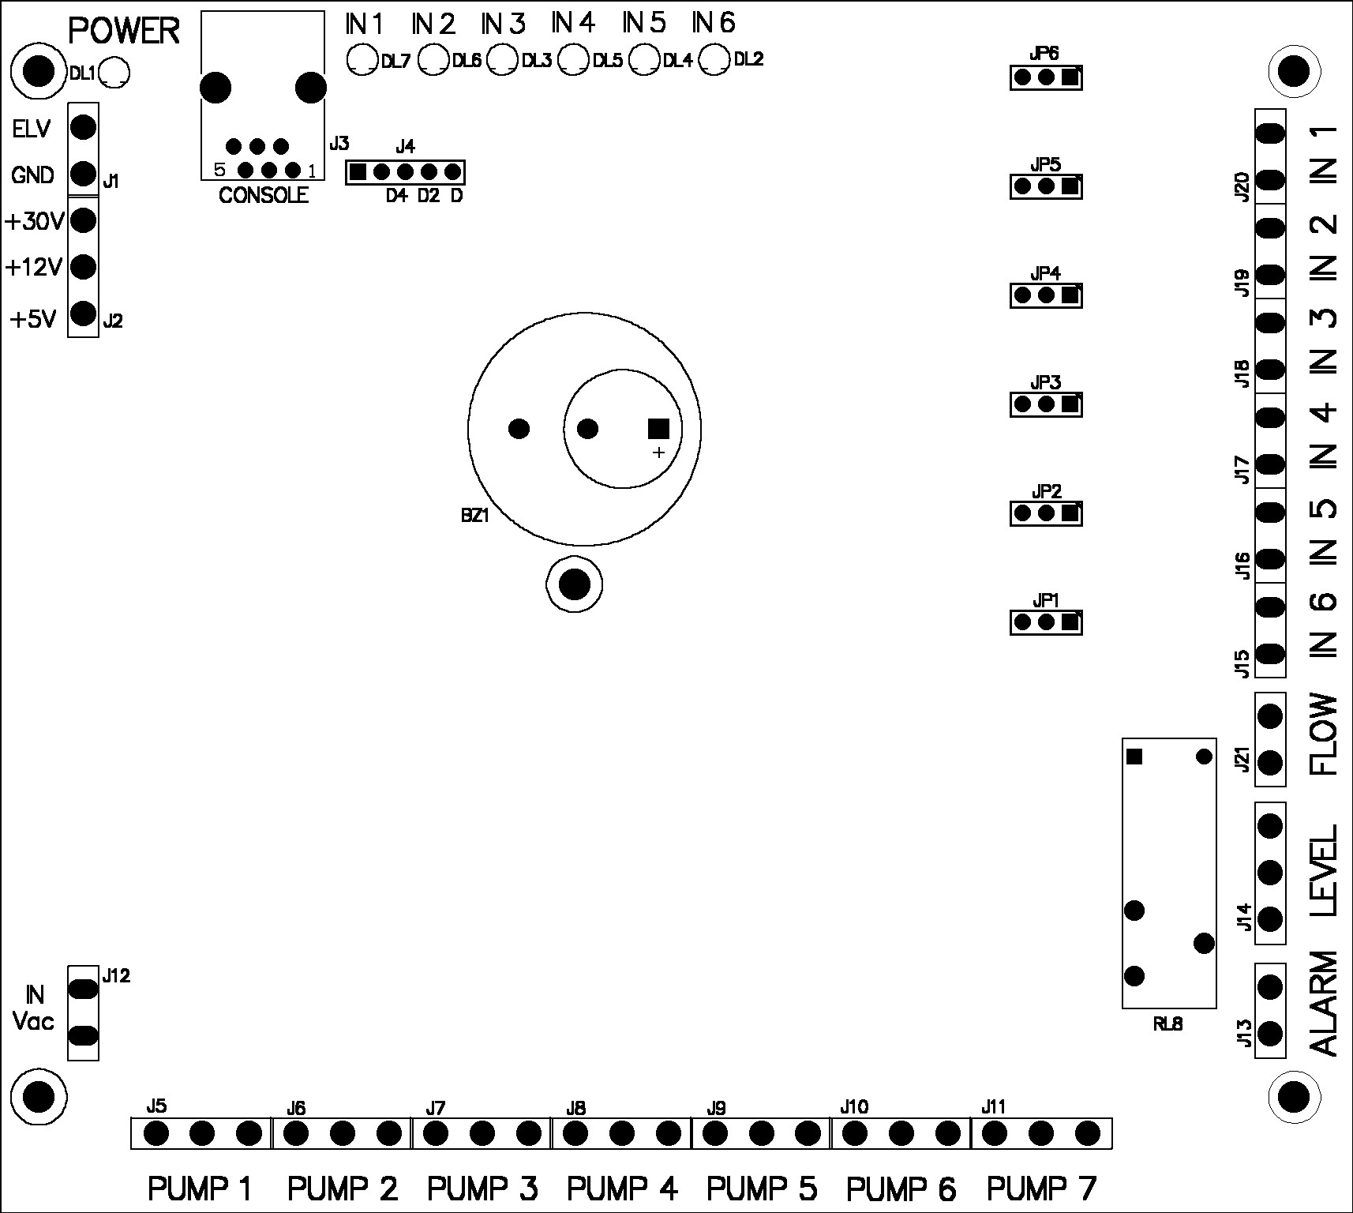
3

2

1

WHITE
GREEN
BROWN

1

Alarm | Output for level alarm (optional)
Level | Input for 7-level monitoring device
Flow | Input for flushing control
IN 1…..IN 6 | Signal inputs: 20Vac - 230Vac or 160Vac - 230Vac
JP1…..JP6 | Selection of input voltage: (IN1-IN6) 20Vac - 230 Vac 160Vac - 230Vac
1 | Relay for level alarm output (optional)
2 | Buzzer
3 | Control console input
Pumps 1…7 | Voltage output for pumps
J1 and J2 | Connected to the power-supply unit
In Vac ref. J12 | Do not use

2.2.2 Power-supply unit circuit diagram
1
Preliminary information

2
Installation
- Wall mounting
- Diagrams: control and power-supply circuits
- Wiring connections
- Selection of flow rate of the pumps
- Hydraulic connections
- Anti-tampering seal

3
Console

4
Level and flush kit

5
Maintenance and accessories

6
Trouble-shooting guide

7
How to contact us

Linear power-supply unit (mod. SMART P)
Switching power-supply unit (mod. SMART H)

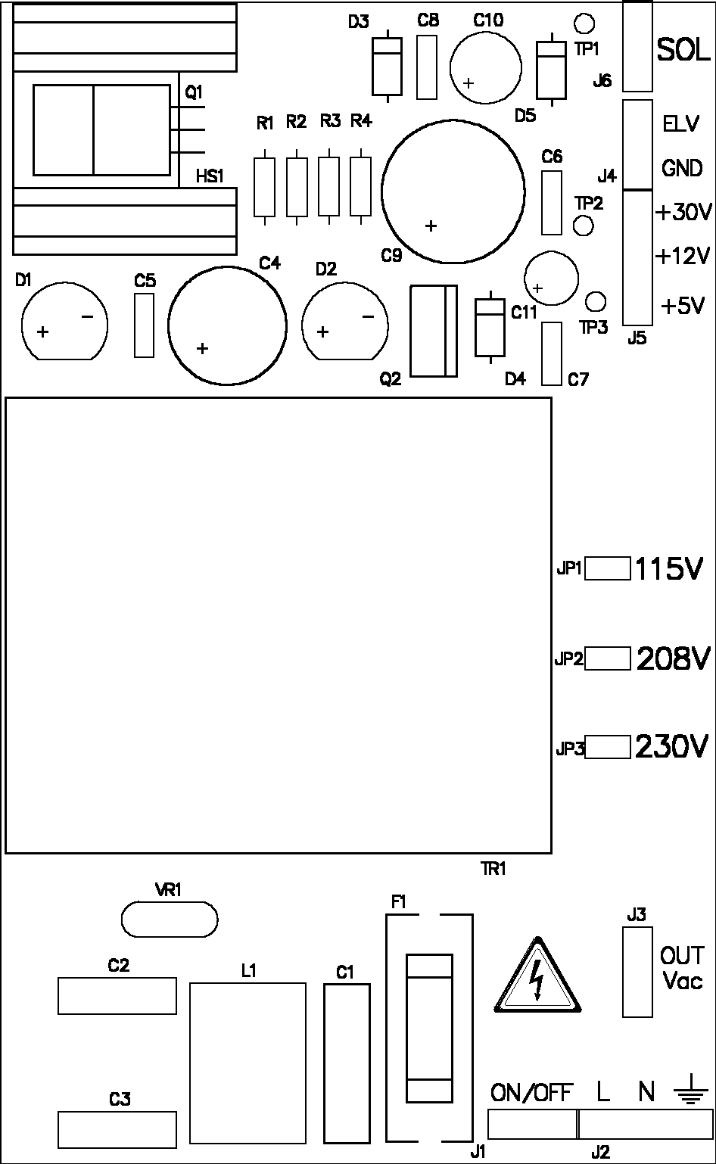
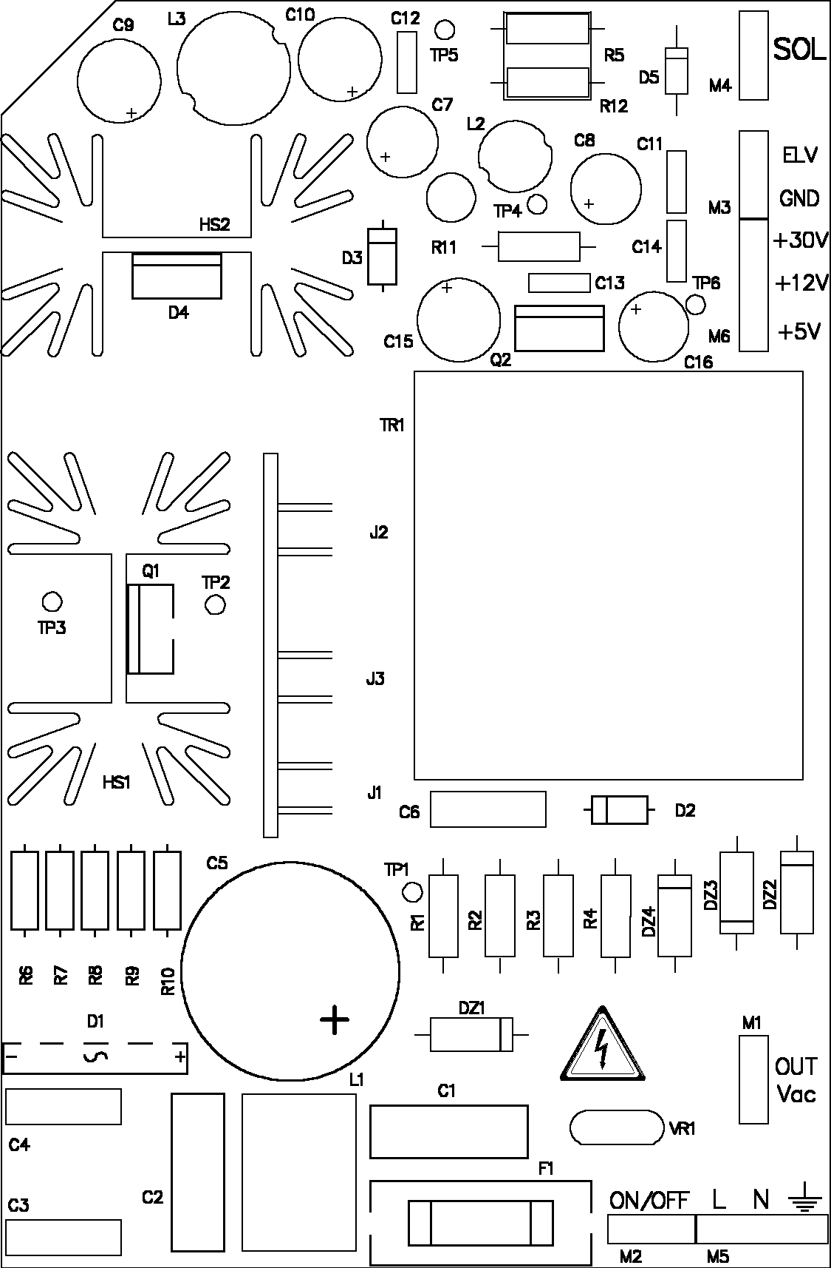

Power-supply input di rete connettore J2

IN POWER J2

Power-supply input di rete connettore M5

IN POWER M5

2.3 Wiring connections
1
Preliminary information

2
Installation
- Wall mounting
- Diagrams: control and power-supply circuits
- Wiring connections
- Selection of flow rate of the pumps
- Hydraulic connections
- Anti-tampering seal

3
Console

4
Level and flush kit

5
Maintenance and accessories

6
Trouble-shooting guide

7
How to contact us

 CAUTION: Always disconnect the SMART System and the laundry machine from the power supply before making any connections.
All the wiring connections to the SMART System should be checked using a multimeter. Incorrect connections could seriously damage the unit and invalidate the warranty. Refer to the wiring diagram contained in this manual for all signalling and power-supply connections.

2.3.1 Power-supply input
Insert the 14-wire cable included in the supply (2x1.5 mm² +12x0.25 mm²) through the cable gland PG11 on the left-hand side of the box and make the connections of the wires, ∅1.5 mm² , on the Power-supply input of the power-supply unit circuit (see point 2.2.2, Diagram of power-supply unit circuit).

- SMART P LINEAR POWER-SUPPLY UNIT (refer to the specific model purchased).
Position the jumper on the required input voltage, 115/208/230 VAC, 50/60 Hz (Picture 3).

 The SMART System is factory set on 230 VAC.
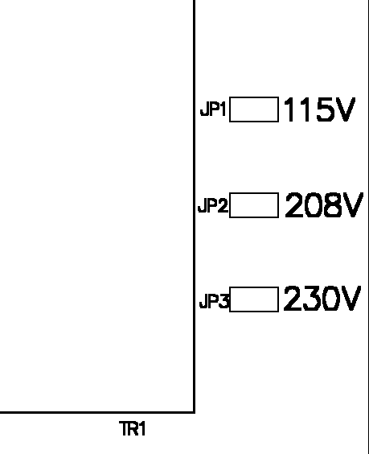
Picture 3
• •

• •

• •
Default setting

- SMART S or H SWITCHING POWER-SUPPLY UNIT (refer to the specific model purchased).
There is no need to make any selections, since the system will accept power-supply voltages from 85 to 230 VAC, 50/60 HZ.

2.3.2 Input signals

- Connect the wires, ∅0.25 mm² , of the 14-wire cable to the solenoid valves of the laundry machine.
- Observing the colour coding used, connect the outputs from the solenoid valves to inputs IN1 to IN6 of the control circuit. Use the jumper to select the voltage recognised by the inputs.
 If you wish to carry out operations controlled by the emptying solenoid valve of the laundry machine, use input IN6 on the control circuit.

Jumpers (JP1 to JP6 on the circuit board) select the input range that is accepted on IN1 to IN6 (Picture 4)
 This selection can be useful when there is a parasitic current that the system could recognise as a signal, even with the solenoid valve not activated.
Default setting

20÷230 V
160÷230 V
Picture 4

2.3.3 Connection of level control (optional)
1
Preliminary information

2
Installation
- Wall mounting
- Diagrams: control and power-supply circuits
- Wiring connections
- Selection of flow rate of the pumps
- Hydraulic connections
- Anti-tampering seal

3
Console

4
Level and flush kit

5
Maintenance and accessories

6
Trouble-shooting guide

7
How to contact us

- Run the cable ∅3x0,25mm (included) into the PG7 cable hold positioned on the left of the Smart box. Tighten the cable gland so as to ensure that the class of protection is maintained.
- Connect the cable of the level control to input J14 LEVEL respecting the colours.
- Refer to the section on the Level control for making the connection and for a description

2.3.4 Connecting the Console
  - Remove the nut securing the cable gland (already fitted onto the cable), then pass the cable through the free hole on the left-hand side of the Smart box. Secure the cable gland to the box with the nut provided for this purpose. Tighten the cable gland in order to ensure proper sealing according to the class of protection.
  - Connect the cable with the telephone plug to the connector marked Console (see point 2.2.1, ref. n° 3.
  - For description and operation, see the Console section in this manual.

2.3.5 Alarm output (upon request)
  - Make a connection to output J13 ALARM.
  - In the event of an alarm, the relay-type contact will close to activate of an external acoustic signal and/or signalling lamp.
 CAUTION: The maximum rating of the relay is 250 VAC 8A.

2.3.6 Flushing alarm (optional)
  - This is already connected to output J21 FLOW by means of the cable coming from the sensor positioned on the flush kit.
  - Refer to the section on the Flushing alarm for operation and for further description.
  - If the system has no sensor for detecting the flow, there will be a jumper on input J21.
  - If a flow-monitoring device is connected at a later time, follow the installation instructions provided with the flow-detection sensor kit.

2.3.7 Existing connections

  - P1 to P7 voltage output for power-supply to pumps (control circuit).
  - Sol 24 VDC voltage output for power-supply to solenoid valve (power-supply unit circuit).

1
Preliminary information

2
Installation
- Wall mounting
- Diagrams: control and power-supply circuits
- Wiring connections
- Selection of flow rate of the pumps
- Hydraulic connections
- Anti-tampering seal

3
Console

4
Level and flush kit

5
Maintenance and accessories

6
Trouble-shooting guide

7
How to contact us

2.4 Selection of the flow rate of the pumps (mod. Smart H only)
In order to optimise the dosing function, on the SMART model H it is possible to select the speed of the motors and therefore the flow rate of the pumps. (Picture 5)

- SMART H (PLUS and BASIC) It is possible to select 30/60/90/120 l/hr

Select the flow rate (expressed in L/h) just moving the jumper on the motor circuit board

➲ Smart H systems are factory set with 60 L/h of flow rate.

 Select the flow rate of the pumps taking the dosing times into consideration.
Example: A typical dosing time of 20 seconds selecting a pumping rate of 60 l/hr would become 40 seconds if a pump in rate of 30 l/hr were selected.

 The P (PLUS and BASIC) version of the SMART System uses pumps with a fixed 18 l/hr flow rate.

2.5 Hydraulic connections
1
Preliminary information

2
Installation
- Wall mounting
- Diagrams: control and power-supply circuits
- Wiring connections
- Selection of flow rate of the pumps
- Hydraulic connections
- Anti-tampering seal

3
Console

4
Level and flush kit

5
Maintenance and accessories

6
Trouble-shooting guide

7
How to contact us

2.5.1 Water-faucet (if there is one)
- Make the connection to the water main (cold water) by means of the water-faucet included in the supply, as shown in the diagram (Picture 6).
Picture 6
WATER MAIN

LAUNDRY MACHINE

SMART SYSTEM
 CAUTION: Look over the connections shown in the Picture. If the connections are made correctly, the valve will only control the flow rate of the water to the SMART System. Delivery to the laundry machine will continue to be direct.

 It is recommended to install the water-faucet included in the supply close to the main water-faucet. This will enable a good flow rate of water to the SMART System even in the event of a low of pressure.

- Connect the delivery tube included in the supply (on “Plus” version only) from the output of the water-faucet to the solenoid valve of the SMART System.
- Delivery tubes of other lengths are also available (see the section on Maintenance and Accessories).

    - Flush kit (if there is one)
The flush kit factory-mounted under the SMART System. It is, however, possible to install it separately, even in a vertical position, by means of the appropriate kit (see the section on Maintenance and Accessories).
The Seko flush kit is equipped with a valve for preventing return of the liquids, both towards the pumps and towards the solenoid valve.
- Connect the output end of the flush kit to the laundry machine by means of a tube with ∅=8mm (it is also possible to make the connection with a tube with ∅ 16 mm, replacing the hose fitting with another provided as a kit, included in the supply). (Picture7).
Size of the output fitting from the flush kit, which can change depending on the models.

Max 1,5 bar
To the laundry machine

Picture 7

The tubes from the flush kit to the pumps are not factory connected to allow pumps calibration. Once terminated this operation (programmer manual par. 4.1.1) connect the tubes to the pumps.

2.5.3 Suction Devices (if supplied)
1
Preliminary information

2
Installation
- Wall mounting
- Diagrams: control and power-supply circuits
- Wiring connections
- Selection of flow rate of the pumps
- Hydraulic connections
- Anti-tampering seal

3
Console

4
Level and flush kit

5
Maintenance and accessories

6
Trouble-shooting guide

7
How to contact us

Seko suction devices are equipped with check valves and adapters for securing them to most types of tank available on the market.
- Introduce the suction devices into the tanks (Picture 8) and connect them by means of tubes to their respective pumps. Tighten the tubes with the metal tube clamps included in the supply.
- Connect the cables (if any) of the suction devices to the level control box (see section about Level Control).
To the pump
To the level control box

Picture 8

Type | Bottom filter | Size (mm) length x diam. | Level-detector probe | Suction device/can adapter | Standard check valve | Available check valve (optional)
Smart Plus | Yes | 450x34 | Yes | Yes | FPM | EPDM
Smart Basic | Yes | 450x34 | No | Yes | FPM | EPDM

 Take care to not leave the suction tube bent.
 Introduce the suction device right to the bottom and fix it in place using the relevant tank adapter so as to prevent it from floating.

 Clean the bottom filter of the suction device whenever a tank containing the product is changed.

2.6 Anti-tampering seal
SMART System boxes are equipped with rings for inserting an anti-tampering seal.
- Smart BOXES: close the boxes and insert the seal through the two rings provided for this purpose.
- Smart CONSOLE: insert the memory card into the console and pass the seal through the hole provided in the card for this purpose and then through the ring on the console box.
 Once the seal has been closed it cannot be re-opened. It will have to be cut open and
a new one will then have to be used. Seals are included in the supply as accessories
(see the section about Maintenance and Accessories).

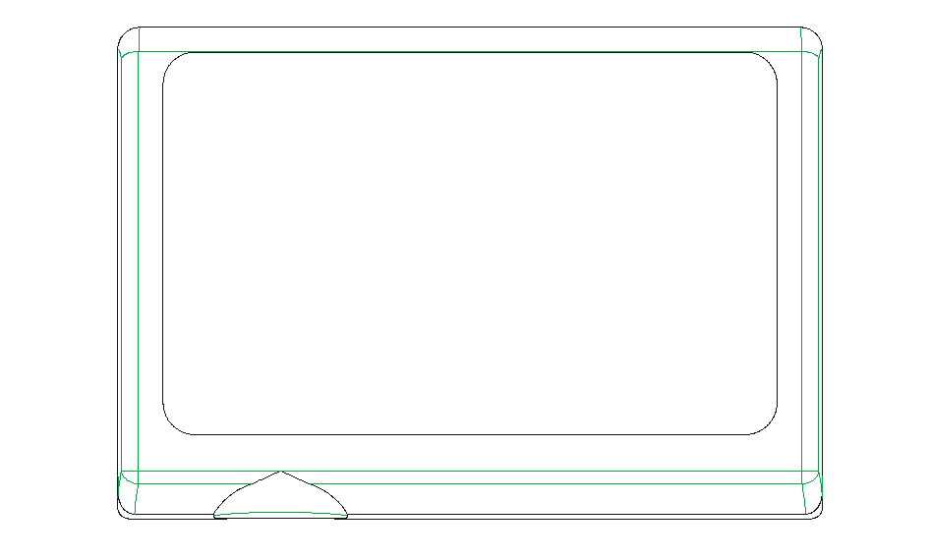
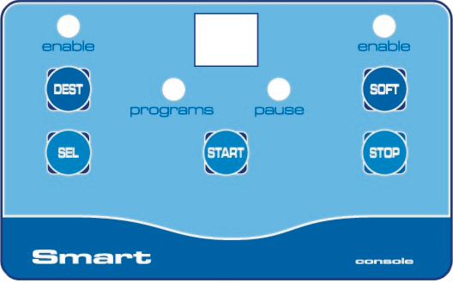
3 Console
1
Preliminary information

2
Installation

3
Console
- Technical specifications
- Description of the operations
- Main controls
- Additional controls

4
Level and flush kit

5
Maintenance and accessories

6
Trouble-shooting guide

7
How to contact us

3.1 Technical specifications
Power-supply requirements | Low voltage supplied from the central unit
Signal interface | Proprietary serial interface
Length of connecting cables | 5 metres
Connector | 6-6 telephone type
Weight | 0.18 Kg
Class of protection | IP 65
Size | 90x123x30 mm (HxLxD)

3.2 Description of the operations

3.2.1 SELECTION OF THE WASHING PROGRAMS IN THE MANUAL MODE
(for selecting the washing program to be run)

- Switching on the system, the console display shows --
- Press [SEL] to select the number of the program to be run;
- Press [START] to start washing (The “Programs” led is flashing)by entering the RUN PROGRAM mode. If the program that has been selected is empty, it cannot be started and the console display shows --.

3.2.2 SELECTION OF THE WASHING PROGRAMS IN THE AUTOWASH MODE
(to select the washing programs in the automatic mode)

- Switching on the system, the console display shows AU;
- The SMART System will wait for one or more input signals IN1 to 6 to be activated in order to start the program to be run;
- When a program is activated, the number of that program will be displayed on the console and the PROGRAMS LED will flash.
- If the program that has been selected is empty, the washingprogram will not start and the display on the console will show AU.

3.2.3 PAUSE THE RUNNING PROGRAM
(while in the RUN PROGRAM mode)
1
Preliminary information

2
Installation

3
Console
- Technical specifications
- Description of the operations
- Main controls
- Additional controls

4
Level and flush kit

5
Maintenance and accessories

6
Trouble-shooting guide

7
How to contact us

- While the washing program is running, to introduce a pause into the system press [STOP]: the system will enter the PAUSE mode (“Programs” and “Pause” leds are steady light).
- Press [START] to resume the washing program from the point where it was stopped and therefore to return to the RUN PROGRAM mode.

3.2.4 TERMINATION OF THE PROGRAM BEING RUN
(while in the RUN PROGRAM mode or during a PAUSE)

- Press the [STOP] key and hold it down for more than three seconds to terminate the washing program and exit. The display will show:
- - - if the system was in the manual mode.
- AU if the system was in the autowash mode.
The system will then return to the SELECT PROGRAM function.

3.2.5 PRIMING THE PUMPS
[In this mode, it is possible to activate a pump (the number of the pump will appear on the display) for periods of 30 seconds. The purpose of this is to prime the pump in question].

During the priming, the solenoid valve will open, if it is set in the automatic mode (see Programmer manual par.4.1) and water will enter in the laundry machine through the flush kit. The solenoid valve will remains open for a few seconds even after priming has been completed, in order to clean the flush kit.
- Press the [STOP] key and hold it down more than 3 seconds until the indication “P1” appears on the display.
- Use the [SEL] key to select the pump to be primed.
- Press [START] to start the priming (this lasts for 30 seconds). It is possible to stop the priming stage by pressing the [STOP] key;
- If the pump is still not primed, repeat point 3;
- To prime the other pumps, repeat the sequence as shown under points 2 to 5.

3.2.6 DIAGNOSTIC MODE
(while in the RUN PROGRAM mode)

This procedure enables the instruction line of the program currently running to be displayed and, if required, changed.
- Set the system in the Pause mode by pressing the [STOP] key (PAUSE LED lights on);
- Press the [SEL] and [STOP] keys: the DIAGNOSTIC MODE is accessed (“Programs” and “Pause” leds are flashing) and the number of the program line currently running will be shown on the display;
- The [SEL] key can be pressed to scroll cyclically through the program lines;
- Press the [STOP] key to resume the program from the last line that has been selected.

3.3 Main controls
1
Preliminary information

2
Installation

3
Console
- Technical specifications
- Description of the operations
- Main controls
- Additional controls

4
Level and flush kit

5
Maintenance and accessories

6
Trouble-shooting guide

7
How to contact us

MODE | KEY | ACTION | FUNCTION
SELECT PROGRAMS  LED:  - PROGRAMS: lights on  - PAUSE : off  Display: shows the number of the program that has been selected: 01 to 20 or “- -“ | [SEL] | Press briefly | To select the next washing program
 | [START] | Press briefly | To start the washing program that has been selected and go into the RUN PROGRAM mode.
 | [STOP] | Keep pressed more than 3 seconds | To place the program in the PRIMING THE PUMPS mode.
RUN PROGRAM  LED:  - PROGRAMS: flashing  - PAUSE : off  Display: shows the number of the program being run | [STOP] | Press briefly | To enter a pause in the washing program being run and go into the PAUSE mode.
 | [STOP] | Keep pressed more than 3 seconds | To stop the washing program, returning the system to the SELECT PROGRAMS mode.
PAUSE  LED:  - PROGRAMS: lights on  - PAUSE : lights on  Display: shows the number of the program in which there is a pause. | [START] | Press briefly | To re-start the program by returning to the RUN PROGRAMS mode.
 | [STOP] + [SEL] | Press simultaneously | This enables the DIAGNOSTICS mode to be accessed.

CAUTION: If the [STOP] key is held down more than 3 seconds, the system returns to the SELECT PROGRAMS mode and the following will be shown on the display:
- - - if the system was in the manual mode.
- AU if the system was in the autowash mode.

3.4 Additional controls
1
Preliminary information

2
Installation

3
Console
- Technical specifications
- Description of the operations
- Main controls
- Additional controls

4
Level and flush kit

5
Maintenance and accessories

6
Trouble-shooting guide

7
How to contact us

MODE | KEY | ACTION | FUNCTION
PRIMING THE PUMPS  LED:  - PROGRAMS: off  - PAUSE : off  display : A letter P is displayed together with the number of the pump that has been selected, 1 to 8 (if the flush kit is used, pump P8 will select the water solenoid valve). | [SEL] | Press briefly | To select the next pump
 | [START] | Press briefly | To activate the pump that has been selected for 30 seconds.
 | [STOP] | Press briefly | To stop the pump (before of 30 seconds).
 | [STOP] | Keep pressed more than 3 seconds | To go into the SELECT PROGRAMS mode.
DIAGNOSTICS  LED:  - PROGRAMS: flashing  - PAUSE : flashing  Display :shows the number of the programming line to be run, 00 to 24 | [SEL] | Press briefly | To scroll the program line number on the display.
 | [STOP] | Press briefly | To return to the RUN PROGRAM mode, carrying out the line that is set on the display

DESTAINER AND SOFTNER

(Only if enabled. See point 4.4.2 of the Programmer Manual)

The DEST (destainer) and/or SOFT (softner) keys on the console can be pressed to enable operation of the pump selected solely for the washing cycle currently in progress. The associated LED will light up.

4 Level monitoring device (optional)
1
Preliminary information

2
Installation

3
Console

4
Level and flush kit

- Technical specifications
- Wall mounting
- Description of the 7-level monitoring device
- Flushing alarm

5
Maintenance and accessories

6
Trouble-shooting guide

7
How to contact us

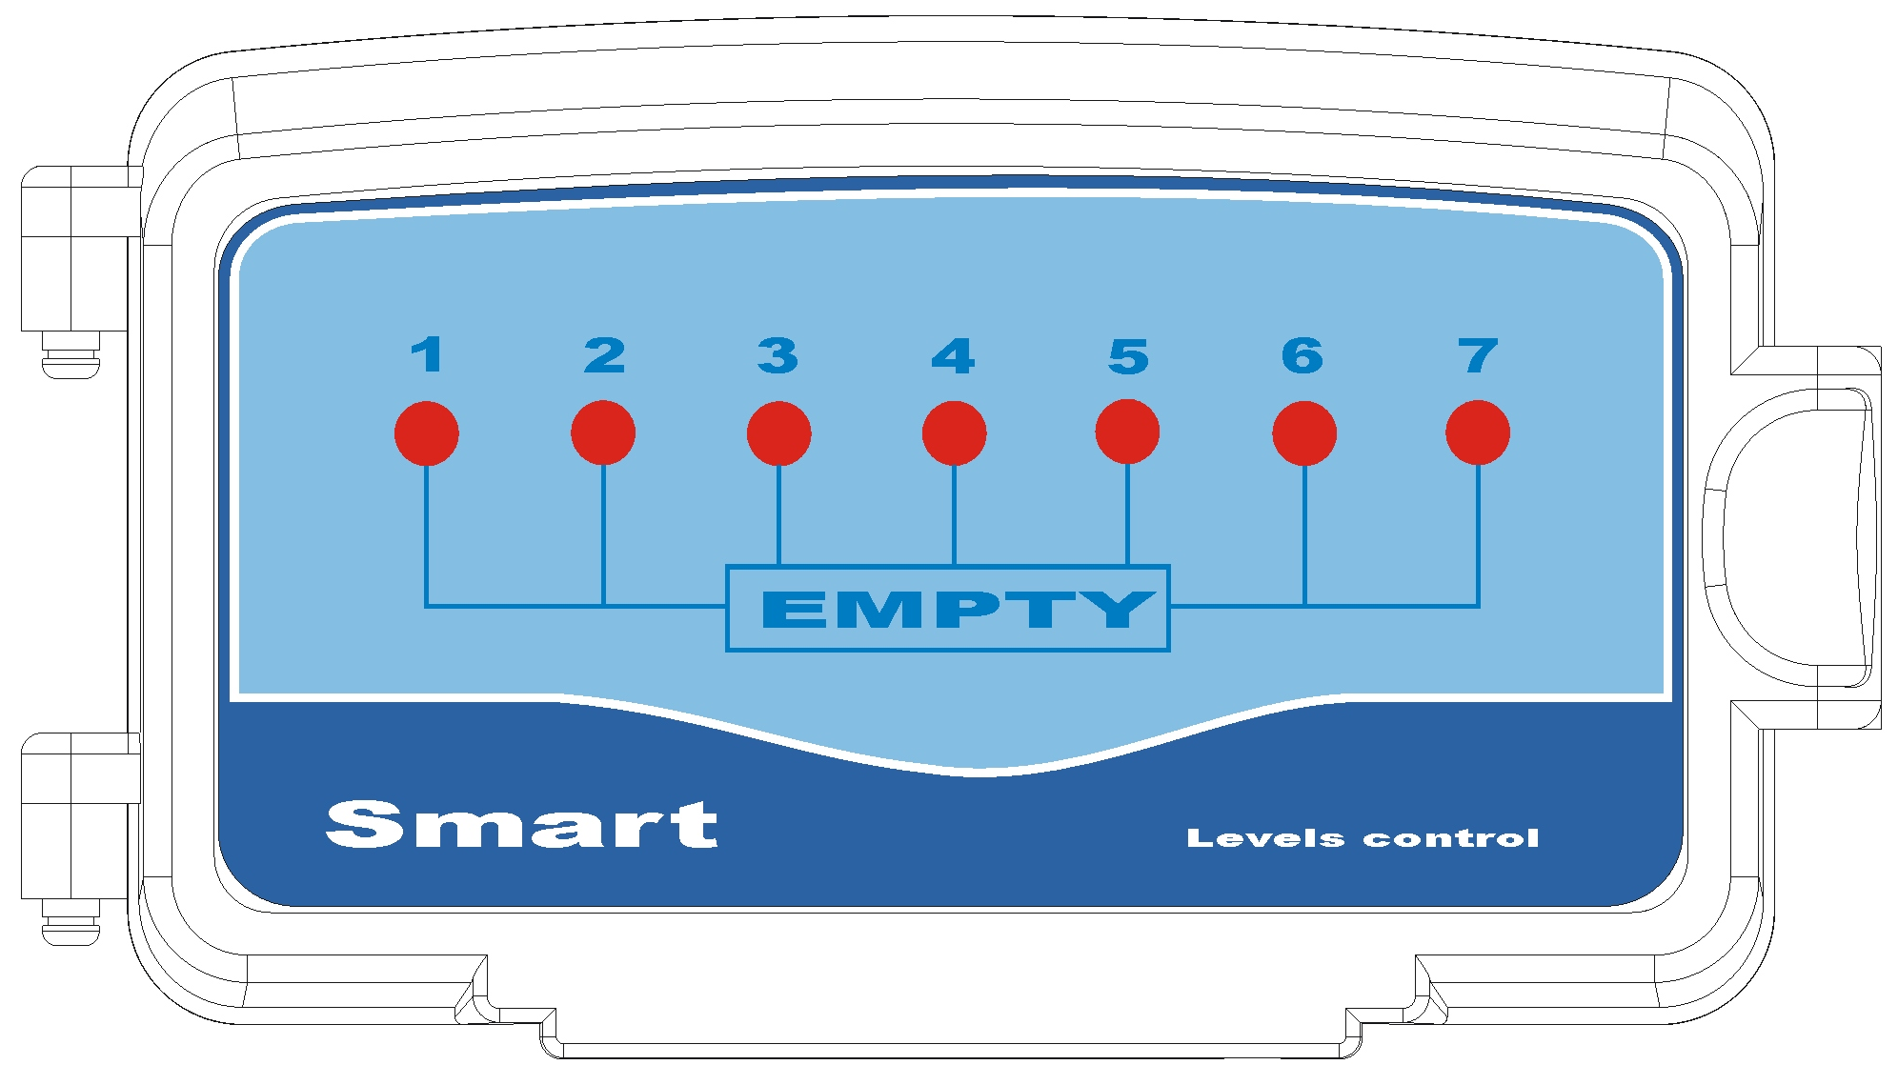

4.1 Technical specifications

Power-supply requirements | Low voltage, supplied from the central unit
Length of connecting cable | 3 metres
Connector | 3-pole, pitch 5 mm
Weight | 0.120 (kg)
Class of protection | IP 65
Size | 75x130x22 mm (HxLxD)

Wall mounting
- Fix the bracket included in the supply to the wall by means of anchor bolts, ∅6mm
- Hang the 7-LEVEL MONITORING DEVICE box from the bracket.
- Open the box and make the connections.

CAUTION: In order to ensure good visibility of the alarm LEDS, it is recommended to install the level control box at eye level.

4.3 Control level device
1
Preliminary information

2
Installation

3
Console

4
Level and flush kit

- Technical specifications
- Wall mounting
- Description of the 7-level monitoring device
- Flushing alarm

5
Maintenance and accessories

6
Trouble-shooting guide

7
How to contact us

If the 7-level alarm is connected, and the low of any products in the tanks is detected, the following events will occur:
- The LED associated with the empty tank will light up on the 7-level monitoring device;
- The alarm output, if any, on the Smart control circuit will be activated (contact closed);
- The buzzer on the Smart control circuit will be activated, buzzing intermittently at a rate of 1 second ON 1 second OFF.
 In the event of a level alarm, the SMART System will continue to function normally.

4.3.1 Connection to the suction devices and level control unit
Open the 7-level control unit box, connect the cable ∅3x0,25mm (included) coming from the SMART control circuit to the “OUT” connector of the Smart control circuit, taking care to observe the colour code, as shown in the Picture:

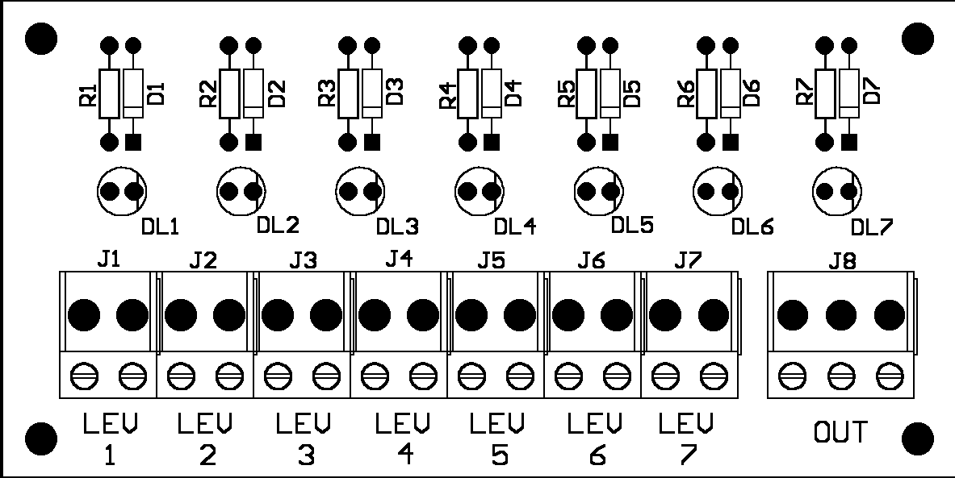
Control circuit
position
J14 LEVEL

BROWN

GREEN

WHITE

 The level monitoring probes should be connected to terminals Lev 1 to 7.

4.4 Flushing alarm (optional)
If a flushing sensor is connected to the system, to the “FLU” connector on the CPU circuit, the SMART System will also monitor the presence of a water flow in the flush kit.
If the system detects this alarm (no water is flowing through), the following events will take place:
- The console display will show: FL;
- The SMART System will stop dosing;
- On the Smart CPU, the alarm output (if any) will be activated (contact closed);
- On the Smart CPU, the buzzer will be activated, buzzing intermittently at a rate of 1 second ON and 1 second OFF.
- The program will automatically be paused;

ACTION: Restore the flow of water then press [START] to resume the program from where it stopped.

POSSIBLE CAUSES: closed faucet, disabled solenoid valve, no water from the main.

5 Maintenance and Accessories
1
Preliminary information

2
Installation

3
Console

4
Level and flush kit

5
Maintenance and accessories
- Maintenance
- Accessories

6
Trouble-shooting guide

7
How to contact us

5.1 Maintenance
 CAUTION: Before carrying out any maintenance, always disconnect the power supply and close the water delivery valve.

Scheduled maintenance of the SMART unit includes the following:
- Regular replacement of the peristaltic tube (every year at least) or whenever required in the event of chemical aggression.
- Cleaning of the filter of the solenoid valve.
- Cleaning of the bottom filters of the suction devices.

 In order to avoid serious scaling, it is recommended that a few washing cycles should be carried out periodically, metering water only. This will eliminate any residues of product.

5.1.2 Replacement of the tubes of the pumps
- Unscrew (if there are any screws) and remove the small cover from the pump;
- Take out the peristaltic tube without disconnecting it from the connecting tubes in order to avoid any leak of product;
- Introduce the new tube (supplied already greased) into the pump;
- Put the front cover back into place;
- Proceeding very cautiously, disconnect the connecting tubes from the old tube and connect them to the new tube in the same positions;
- It will be advisable to prime the pump before starting the machine again.

5.2 Accessories
Seko can supply a complete range of accessories for making the installation operations easier.

- Wall mounting kit for flush kit:………………. item n° 9900106331
  - This is used to secure the flush kit to a wall, in a vertical position if required, so as to facilitate drainage of the liquids. The kit includes 2 mounting brackets, 2 anchor bolts - ∅ 6 mm - and 5 metres of PVC piping ∅8x12mm.
- Programmer……………………item n° 9900700020
- CD with the software for remote programming of the memory card and 1.8 m of serial cable. …………………………….item n° 9900106332
  - Delivery tube, 20 bars. 3/4F-3/4F, available in the following lengths:
  - 2 m…………….item n° 990090123
  - 3 m…………….item n° 990090124
  - 4 m…………….item n° 990090125
  - 5 m…………….item n° 990090126
  - 50 m of 14-wire cable (2x1.5mm² +12x0.25mm²)……….. item n° 0000602088
  - 100 m of PVC crystal piping ∅8x12mm…………………… item n° 9900090090
  - 50 anti-tampering seals……………………………………… item n° 9900106333

6 Trouble-shooting guide

1
Preliminary information

2
Installation

3
Console

4
Level and flush kit

5
Maintenance and accessories

6
Trouble-shooting guide

7
How to contact us

6.1 Errors shown on the display
- EE Check whether the memory card has been inserted correctly.
- EE Check that the memory card being used is the Program Memory Card.

  - One or more pumps are not working:
If one or more pumps do not carry out the dosing according to the program during normal operation, check the following:
- Make sure that the pumps are correctly connected to the inputs: PUMP 1 to 7.
- Make sure that the pumps have not been enabled for delivery of destainer or softner (manual dosing).

  - The pumps are running but the product is not being metered
- Check the suction tube for any kinks.
- Check the bottom valves of the suction devices to see if they are clogged.

6.4 Solenoid valve
If the solenoid valve does not work, check the following:
- Make sure it is correctly connected to the circuit in the SOL position.
- Make sure that there is a proper flow of incoming water (valve open).
- Make sure that automatic opening has been enabled (FLU=AUT).

6.5 After replacing an empty tank, the level alarm of the system persists:
- This may happen with products that have a high viscosity. Wait for a few seconds in order to allow the float of the suction device to return to its normal position.

7 Contacting SEKO

1
Preliminary information

2
Installation

3
Console

4
Level and flush kit

5
Maintenance and accessories

6
Trouble-shooting guide

7
How to contact us

Seko group
Via salaria Km 92.200 – 02010 S. Rufina (RI) –Italia
Web site: www.seko.it Email: info@seko.it



SEKO Italia
SEKO Asia pacific
SEKO Brasil
SEKO Deutschland
SEKO France
SEKO Iberica
SEKO Southern Africa
SEKO UK
SEKO USA

